

**HIGH LEVEL DESIGN (HLD) SIGN-OFF**

**Authorization Memorandum**

This form is to sign-off completion of the Design Phase for **CAMPUS MANAGEMENT SOFTWARE AT WORLD SKILL CENTER (WSC).**

World Skill Centre (WSC) acknowledges receipt of the deliverables as part of the Design Phase through the submission of this document.

|  |  |
| --- | --- |
| **MODULE NAME** | **Infrastructure: Infrastructure Management and Maintenance** |
| **MODULE OWNER** | **Mr. Brahmananda Sahoo / Mr. Kerwin Hing** |

**WSC AUTHORITY NAME AND SIGNATURE**

**SOUL AUTHORITY NAME AND SIGNATURE**

**High Level Design (HLD)**

Of

**Infrastructure Management and Maintenance**

For Implementation of

**Campus Management Software**

at

**World Skill Center (WSC)**

**Sustainable Outreach And Universal**

**Leadership (SOUL) Limited**

**Confidentiality**

This document is a strictly confidential communication to and solely for the use of the recipient and may not be reproduced or circulated without SOUL Ltd’s prior written consent. If you are not the intended recipient, you may not disclose or use the information in this documentation in any way

**Document Control History**

|  |  |  |  |  |
| --- | --- | --- | --- | --- |
| **Date** | **Version No.** | **Created By** | **Affected Sections** | **Reviewed By** |
| 18-July-2023 | 1.0 | Subhodeep Dey | All |  |
| 21-July-2023 | 1.1 |  | All | Sharmistha Panda |

# Project Control

|  |  |
| --- | --- |
| **Package Number:** | PKG 0111 |
| **Project Name:** | Campus Management Software At World Skill Center (WSC) |
| **Location:** | Bhubaneswar |
| **Customer Name:** | World Skill Center (WSC) |
| **Customer Contact Information:** | Mancheswar, Bhubaneswar |
| **Project Manager / Email ID:** | Sharmistha Panda  sharmistha.panda@soulunileaders.com |
| **Module SME / Email ID:** | Mr.Brahmananda Sahoo / Mr. Kerwin Hing  [brahmananda.sahoo@worldskillcenter.org](mailto:brahmananda.sahoo@worldskillcenter.org)  kerwin.hing@worldskillcenter.org |

Table Of Contents

HIGH LEVEL DESIGN (HLD) SIGN-OFF 1

Authorization Memorandum 1

Project Control 3

1 Introduction 7

1.1 Background 7

1.2 Scope and Purpose of the document 7

1.3 Assumptions 8

1.4 Dependencies 8

1.5 Current IT Environment 8

1.6 Document Structure 8

1.7 Required System Architecture 9

1.8 Interoperability Framework 9

1.9 Technical Decision Summary 10

1.10 Architectural Risks & Mitigation 10

1.11 Reference 11

2 Enterprise Architecture Framework (Business Architecture) 11

2.1 Business Drivers 11

2.2 Business Concerns 11

2.3 Business Goals 11

2.4 Business Value Chain 11

2.5 Business Context Diagram 12

2.6 Business Process Flow 12

2.6.1 Infrastructure Management and Maintenance 12

2.6.2 System Context Diagram 13

2.7 Conceptual Architecture 13

3 Architecture Views 14

3.1 Land 14

3.1.1 Use Case Diagram 14

3.1.2 Design Workflow 15

3.1.3 Validations 15

3.1.4 Field List: 15

3.1.5 Processes After Form Submission 16

3.1.6 Process Flow: 16

3.1.7 Pre-requisites and Dependency 17

3.2 Building 17

3.2.1 Use Case Diagram 17

3.2.2 Design of Workflow 18

3.2.3 Validations 18

3.2.4 Field List: 19

3.2.5 Processes After Form Submission 20

3.2.6 Process Flow: 20

3.2.7 Pre-requisites and Dependency 20

3.3 Floor 20

3.3.1 Use Case Diagram 20

3.3.2 Design of Workflow 21

3.3.3 Validations 21

3.3.4 Field List: 22

3.3.5 Processes After Form Submission 22

3.3.6 Process Flow: 22

3.3.7 Pre-requisites and Dependency 23

3.4 Building Room 23

3.4.1 Use Case Diagram 23

3.4.2 Design of Workflow 24

3.4.3 Validations 24

3.4.4 Field List: 25

3.4.5 Processes After Form Submission 25

3.4.6 Process Flow: 26

3.4.7 Pre-requisites and Dependency 26

3.5 Building Type Room 26

3.5.1 Use Case Diagram 26

3.5.2 Design of Workflow 27

3.5.3 Validations 27

3.5.4 Field List: 27

3.5.5 Processes After Form Submission 28

3.5.6 Process Flow: 28

3.5.7 Pre-requisites and Dependency 28

3.6 Asset 28

3.6.1 Use Case Diagram 28

3.6.2 Design of Workflow 29

3.6.3 Validations 29

3.6.4 Field List: 30

3.6.5 Processes After Form Submission 33

3.6.6 Process Flow: 34

3.6.7 Pre-requisites and Dependency 34

3.7 Asset Maintenance Team 34

3.7.1 Use Case Diagram 34

3.7.2 Design of Workflow 35

3.7.3 Validations 35

3.7.4 Field List: 36

3.7.5 Processes After Form Submission 36

3.7.6 Process Flow: 36

3.7.7 Pre-requisites and Dependency 37

3.8 Asset Maintenance 37

3.8.1 Use Case Diagram 37

3.8.2 Design of Workflow 38

3.8.3 Validations 38

3.8.4 Field List: 39

3.8.5 Processes After Form Submission 40

3.8.6 Process Flow: 40

3.8.7 Pre-requisites and Dependency 40

3.9 Asset Maintenance Log 40

3.9.1 Use Case Diagram 40

3.9.2 Design of Workflow 41

3.9.3 Validations 41

3.9.4 Field List: 42

3.9.5 Processes After Form Submission 42

3.9.6 Process Flow: 42

3.9.7 Pre-requisites and Dependency 43

3.10 Asset Repair 43

3.10.1 Use Case Diagram 43

3.10.2 Design of Workflow 44

3.10.3 Validations 44

3.10.4 Field List: 44

3.10.5 Processes After Form Submission 46

3.10.6 Process Flow: 46

3.10.7 Pre-requisites and Dependency 47

4 Tools And Technologies 47

5 Non-Functional Requirements 47

5.1 Performance 47

5.2 Reliability 47

5.3 Usability 48

5.4 Compatibility 48

5.5 Security 48

5.6 Compliance 48

5.7 Documentation 48

5.8 Security: User access and authorization 48

Prototype 51

6 Prototype 52

6.1 Land 52

Figure : Land 52

6.2 Building 52

6.3 Floor 52

6.4 Building Room 53

6.5 Building Type Room 53

6.6 Asset 54

6.7 Asset Maintenance Team 54

6.8 Asset Maintenance 54

6.9 Asset Maintenance Log 55

6.10 Asset Repair 55

7 Definitions and Acronyms 56

8 Deployment Description 56

# Introduction

The World Skill Center (WSC) is a premier advanced skill training institute established by the Government of Odisha, Skill Development and Technical Education Department, through the Odisha Skill Development Authority (OSDA). The WSC will impart advanced skill training in eight trades from engineering and service sectors. WSC caters primarily to induct the best talent from ITIs and Polytechnics and train them to become globally employable in emerging areas such as "Industry 4.0". WSC is housed in a state-of-the-art, 18-storey, air-conditioned building with nearly half a million square feet of space in the heart of capital city of Bhubaneswar.

With the implementation of campus management software for WSC the goal is to streamline the operations and functions of the campus by integrating various processes, such as admissions, course registration, academic progress tracking, and financial management, HRMS, Procurement and Inventory management, etc into a unified system. The implementation also aims at providing a user-friendly interface for all stakeholders, making it easier for them to access the necessary information and complete their tasks with ease. The modules to be covered during the implementation of the software include:

|  |  |
| --- | --- |
| Students Management Modules | Infrastructure Management |
| Academic System | Finance and Accounting System |
| Procurement & Inventory Management | Training and Placement |
| Human Resources Management System | Application Integration |

# 

## Background

The Web Based Campus Management Application at World Skill Centre (WSC) application is required by WSC for the smooth operation of all departments / support functions with on-line delivery of services to all stakeholders.

The project aims to create a mechanism to provide the basis for evolution of an IT enabled state of the art workflow automation system in a planned manner.

## Scope and Purpose of the document

The design documents track the necessary information required to effectively define architecture and system design in order to give the development team guidance on the architecture of the system to be developed. Its intended audience is the project manager, project team, and development team. Some portions of this document, such as the user interface (UI), may be shared with the client/user, and other stakeholders whose input/approval into the UI is needed.

This document covers all the design aspects of Infrastructure Management and Maintenance of ERP Product. This module helps in organizing the projects and tasks. This module covers the need of an organization to track and update each of their processes to stay afloat and grow in the industry. The Infrastructure Management and Maintenance module helps an organization to keep track of such deliverable and ensure their timely completion.

The scope of Infrastructure - Infrastructure Management and Maintenance Tool module

* Master data for Land, Buildings and Floor
* Room Master
* Asset Maintenance and AMC

## Assumptions

The assumptions are listed as follows:

* The hardware and software requirements will be provided as specified
* Data loading to be handled by WSC

All external entities will provide their interface for application integration

## Dependencies

The ERP system will be dependant on external interfaces for integration services. Following are few external interfaces:

* Payment Gateway
* Communication channels such as – Email, SMS, WhatsApp
* Microsoft 365
* Biometric System
* Website

## Current IT Environment

|  |  |
| --- | --- |
| **Hardware Requirements** | **Software Requirements** |
| Processor: Intel CPU with at least 8 cores | Operating System: Ubuntu 22.04 LTS |
| RAM: 16 GB to 32 GB | Web Server: Nginx |
| Storage: A minimum of 160 GB SSD | Database server: MariaDB |
| Network: 1 Gbps | Python: 3.10 or later |

## Document Structure

The following sections are part of this document :

* Business goals, objectives and requirements
* Understand business context and interactions
* Conceptual design
* Overall system context
* Understand use-case and scenarios
* Define implementation

## Required System Architecture

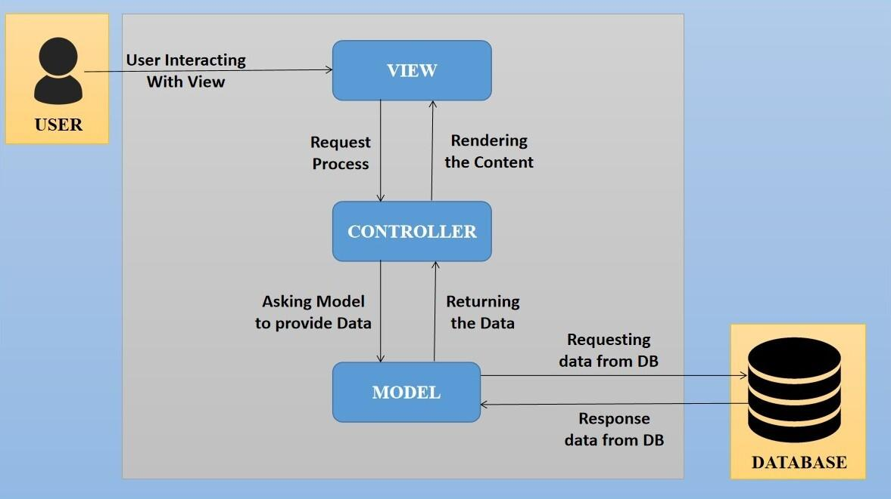

The proposed design is an architectural pattern that separates an application into three main logical

components: The **Model**, the **View** and the **Controller**. Each of these components are built to handle

specific development aspects of the application like:

* The Model component corresponds to all the data-related logic that the user works with. This can represent either the data that is being transferred between the View and Controller components or any other business logic-related data
* The View component is used for all the UI logic of the application. It generates a user interface for the user
* The controller is the component that enables the interconnection between the views and the model so it acts as an intermediary

## Interoperability Framework

Frappe is a full stack, batteries-included, web framework written in Python and JavaScript with MariaDB as the database. It is pretty generic and can be used to build database-driven apps with an elegant and consistent UI.

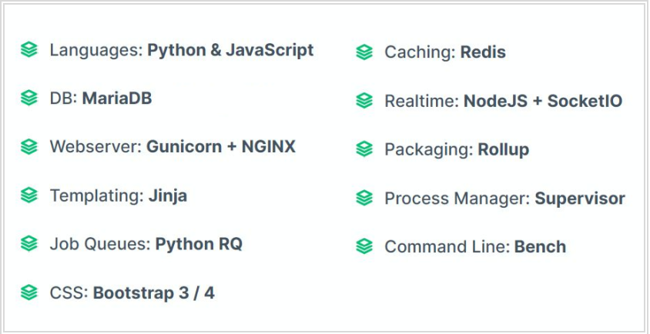

## Technical Decision Summary

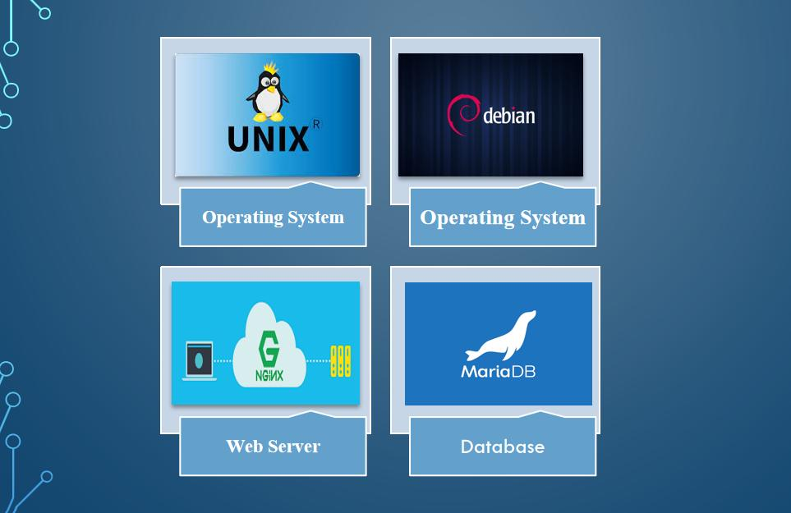

## Architectural Risks & Mitigation

|  |  |
| --- | --- |
| **Risks** | **Recommendation** |
| Inability to provide the required hardware resources (Server) for installation of the ERP product | The issue should be brought up during cadence meetings, and the OCAC/WSC IT team should assure timely availability of the required server |
| Unavailability of API for third party integration | The project timeline schedule needs to be shared with third parties to avoid the delay in integration. Also, inclusion of external teams to meet timelines |

## Reference

|  |  |
| --- | --- |
| ***Sl No.*** | ***Document Name*** |
| 1 | SRS for Infrastructure Management and Maintenance |
|  |  |

# Enterprise Architecture Framework (Business Architecture)

## Business Drivers

The following points motivate the business efficacy of Campus Management Software at World Skill Center (WSC) system:

* Integrate the various functions such as Admission, Academics, Examination, Training & Placement, HRMS, Procurement, Finance into a single platform which can be customized as per user requirements
* Implement a common framework for the system and sub systems
* Provide web based application for the users to interact with the system with Role based Access and consistent look and feel

## Business Concerns

Campus Management Software At World Skill Center application is designed to address the following concerns:

Student Management: To help the students / trainers manage the students admission activities, starting from initial communication to course enrollment

Financial Management: Managing finances is a fundamental concern for businesses. This includes budgeting, cash flow management, ledger maintenance, balance sheet,etc

Employee Engagement: Attracting, retaining, and engaging skilled and motivated employees is critical. Human resources concerns also include training, performance management

Procurement management: The source-to-settle process. It encompasses the evaluation, selection, and creation of formal contractual agreements as well as managing the company's ongoing supplier relationships

## Business Goals

The goal is to implement a web based Campus Management Application System for efficient internal functioning of World Skill Center (WSC) with on-line delivery of services to each stakeholder of WSC supported by a suitable, robust, secure and reliable system

## Business Value Chain

The ERP system's business value chain typically encompasses the following key components:

Procurement Management: This includes the processes related to sourcing and acquiring raw materials, goods, or services required for the organization's operations. The ERP system streamlines procurement activities, such as supplier management, purchase requisitions, purchase orders, and inventory management, leading to cost savings and better supply chain management.

Production/Operations Management: The ERP system facilitates the planning, scheduling, and execution of production processes. It optimizes resource allocation, tracks work progress, manages bills of materials, and monitors production costs to enhance overall operational efficiency and quality.

Inventory Management: The ERP system enables real-time tracking of inventory levels, stock movements, and stock outs. It helps in maintaining optimal inventory levels, reducing carrying costs, and ensuring timely availability of products.

Financial Management: ERP systems centralize financial data and automate accounting, financial reporting, budgeting, and financial analysis. This streamlines financial processes, enhances accuracy, and provides management with a clear financial overview for better decision-making.

Human Resources Management: ERP systems handle various HR functions, including payroll, employee records, recruitment, performance management, and training. This leads to streamlined HR processes, improved workforce management, and enhanced employee satisfaction.

## Business Context Diagram

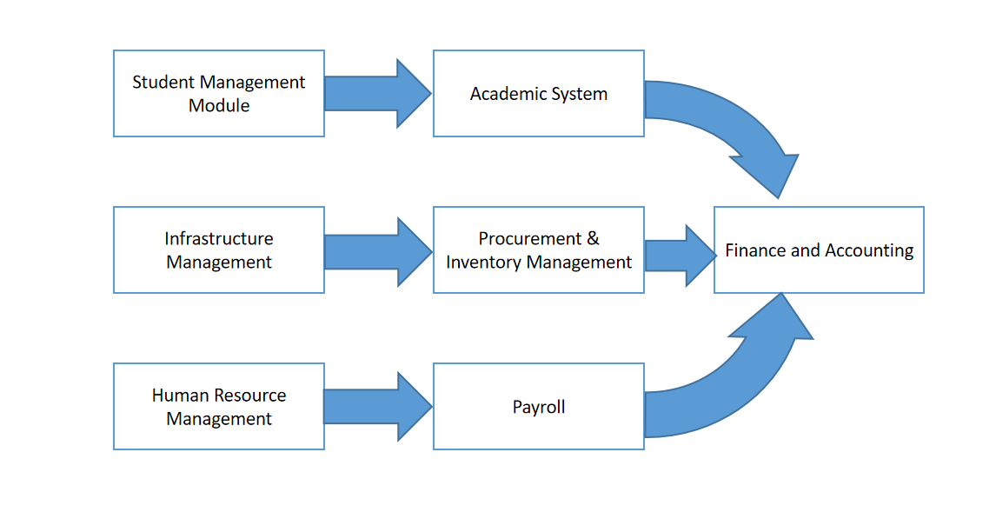

## Business Process Flow

### Infrastructure Management and Maintenance

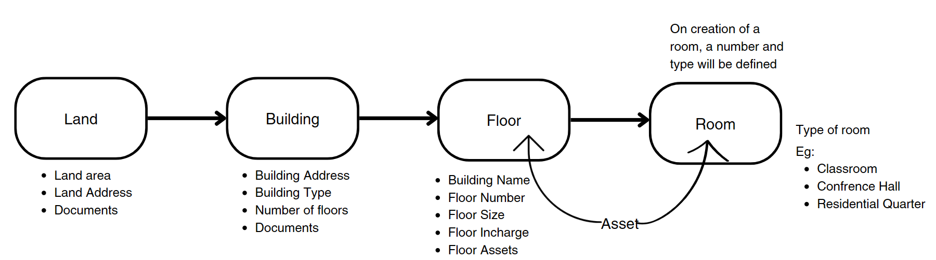

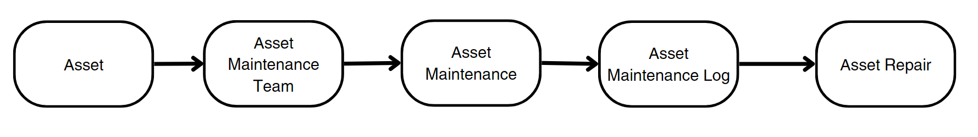

### 

### System Context Diagram

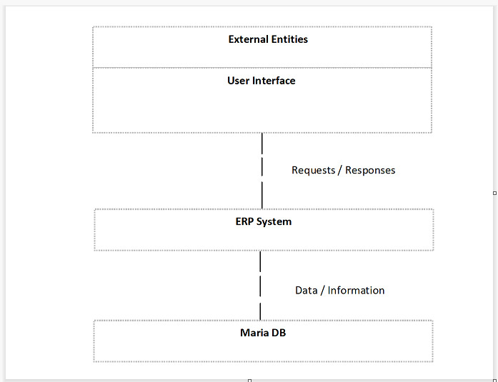

## Conceptual Architecture

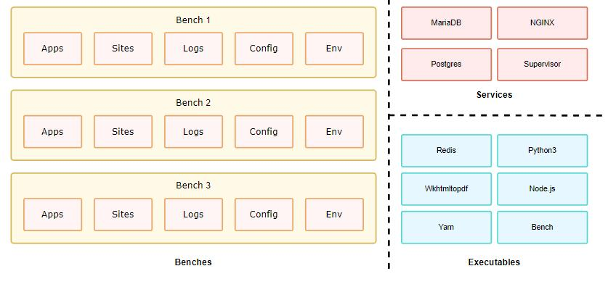

A single bench can host multiple combinations of sites and apps. For the most part, having a single bench works for hosting hundreds of sites that depend on the same versions of said app, given you've scaled up the workers. You can host multiple versions of the application on the same server by creating multiple benches parallelly. The following diagram hints to the system dependencies and how they are used.

# Architecture Views

## Land

This is a master screen which holds data regarding the land. Land here is in reference to the plot of land on which the building is built. The Land Master shall have attachment buttons for Allotment Letter and other documents.

### Use Case Diagram

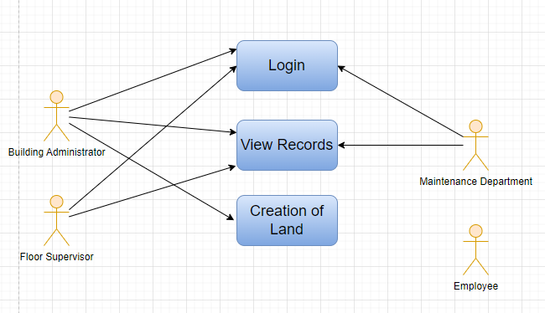

### 

### Design Workflow

* Design workflow is not applicable to this screen as records in this are created by only one role and are not sent to users with other roles for approval or modification.

### Validations

**Client Side Validation :**

Client-side validation refers to the process of validating user input directly on the client's web browser before saving it to the server for further processing.

The following validations are done on client side for Land Screen:

* Mandatory checks for fields : Name, Address, Phone, Email, Property on lease, Lease, Plot number, Land Complete Address, Land Size, Start Date, End Date, Land Use
* Linked Fields : Not Applicable

**Server Side Validation :**

Server-side validation refers to the process of validating user input on the server to ensure data integrity, security, and adherence to business rules before accepting or processing the information. Following are some server side validations done for Land screen:

* dateValidate(self) - this definition checks if start date is less than end date else throws an error message
* pincode(self) - this definition checks if the pin_code field has exactly 6 digits else throws an error message

**Notification:**

* This section is not applicable since there is no notifications to be triggered

### Field List:

|  |  |  |  |  |  |
| --- | --- | --- | --- | --- | --- |
| **ID** | **Field Label** | **Field Type** | **Validation/Action** | **Mandatory** | **Remarks** |
| 1 | Name | Text Field |  | Y |  |
| 2 | Address | Text Field |  | Y |  |
| 3 | Phone | Text Field |  | Y |  |
| 4 | Email | Text Field |  | Y |  |
| 5 | Property on lease | Select | Yes  No | Y |  |
| 6 | Lease | Attach |  |  |  |
| 7 | Plot number | Data |  | Y |  |
| 8 | Land Complete Address | Small Text Field |  | Y |  |
| 9 | Pin code | Text Field |  |  |  |
| 10 | Land Size | Text Field |  | Y |  |
| 11 | Land Valuation | Currency |  |  |  |
| 12 | Start Date | Date |  | Y |  |
| 13 | End Date | Date |  | Y |  |
| 14 | Land Use | Drop down | Academic  Residential  Others | Y |  |
| 15 | Land Use, If others | Text Field |  | Display Depends on Land use drop down selection(others) |  |
| 16 | Date of Planned Development | Date |  |  |  |
| **17** | **Land Documents** | Table |  |  |  |

|  |  |  |  |  |  |
| --- | --- | --- | --- | --- | --- |
| **Land Documents** | | | | | |
| **ID** | **Field Label** | **Field Type** | **Validation/Action** | **Mandatory** | **Remarks** |
| 1 | Document Name | Text Field | User Input |  |  |
| 2 | Document | Attach Button |  |  |  |

### Processes After Form Submission

* This section is not applicable since the form is not submittable.

### Process Flow:

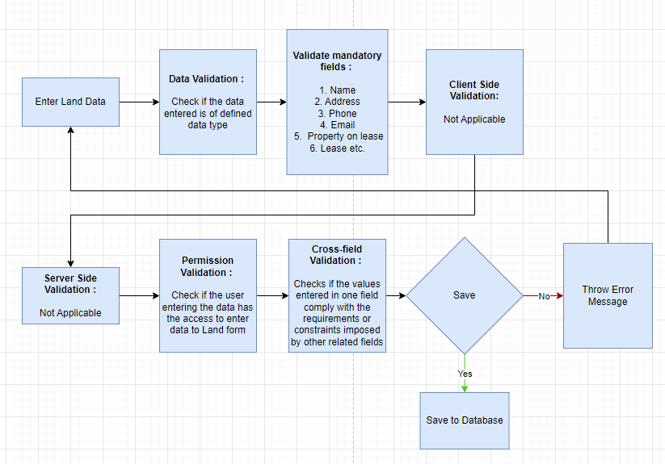

### Pre-requisites and Dependency

* Not Applicable

## Building

This is a master screen for buildings. All the building information shall be stored here including documents like Building Letter(Records of right and Building design), Fire Approval, Electrical Inspection, etc. The buildings can be residential, academic or both. The actions on this screen can be performed by the administrator only.

### Use Case Diagram

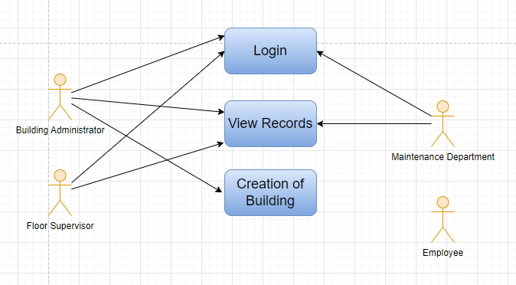

### Design of Workflow

* Design workflow is not applicable to this screen as records in this are created by only one role and are not sent to users with other roles for approval or modification.

### Validations

**Client Side Validation:**

Client-side validation refers to the process of validating user input directly on the client's web browser before saving it to the server for further processing.

The following validations are done on client side for Building Screen:

* Mandatory checks for fields: Building Name, Building Address, Post Office, District, State, Pin Code, Building on Lease, Lease, Building Type, Total Floors, Facing
* Linked Fields: The District name field is linked with the Districts Screen. The Land Plot number name field is linked with the Land Screen.

**Server Side Validation:**

Server-side validation refers to the process of validating user input on the server to ensure data integrity, security, and adherence to business rules before accepting or processing the information. Following are some server side validations done for Building screen:

* dateValidate(self) - this definition checks if start date is less than end date else throws an error message
* pincode(self) - this definition checks if the pin_code field has exactly 6 digits else throws an error message

**Notification:**

* This section is not applicable since there is no notifications to be triggered

### Field List:

|  |  |  |  |  |  |
| --- | --- | --- | --- | --- | --- |
| **ID** | **Field Label** | **Field Type** | **Validation/Action** | **Mandatory** | **Remarks** |
| 1 | Land Plot number | Link Field | Fetched from Land master screen |  |  |
| 2 | Land Address | Text Field | Auto fetch based on Land Plot Number |  |  |
| 3 | Building Name | Text Field | User Input | Y |  |
| 4 | Building Address | Text Field |  | Y |  |
| 5 | Post Office | Text Field |  | Y |  |
| 6 | District | Link Field | Districts | Y |  |
| 7 | State | Text Field |  | Y |  |
| 8 | Pin Code | Text Field |  | Y |  |
| 9 | Building on Lease | Drop down | Yes  No | Y |  |
| 10 | Lease | Attach | Display Depends on “Building on Lease” | Y |  |
| 11 | Building Type | Drop down | Academic  Administrative  Others | Y |  |
| 12 | Building Type, if any other | Text Field |  | Display Depends on “Building Type” drop down selection(others) |  |
| 13 | Total Rooms | Integer Field |  |  |  |
| 14 | Total Floors | Integer Field |  | Y |  |
| 15 | Facing | Drop down | North  South  East  West | Y |  |
| 16 | Campus | Text Field |  |  |  |
| 17 | Start date | Date picker |  |  |  |
| 18 | End date | Date picker |  |  |  |
| **19** | **Building Documents** | Attach |  |  |  |

|  |  |  |  |  |  |
| --- | --- | --- | --- | --- | --- |
| **Building Documents** | | | | | |
| **ID** | **Field Label** | **Field Type** | **Validation/Action** | **Mandatory** | **Remarks** |
| 1 | Document Name | Text Field |  |  |  |
| 2 | Document | Attach Button |  |  |  |

### Processes After Form Submission

* This section is not applicable since the form is not submittable.

### Process Flow:

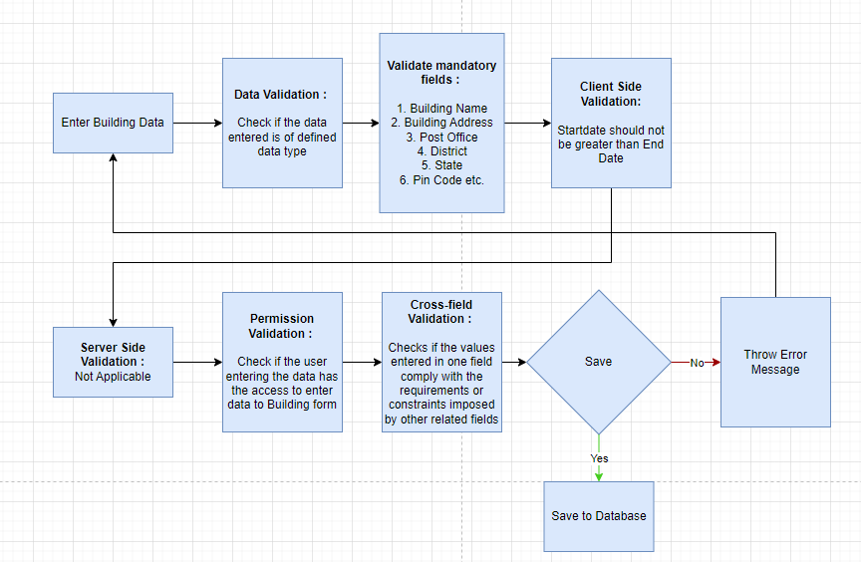

### Pre-requisites and Dependency

* District, Land Plot number

## Floor

The Floor Master Screen is a screen which will help the user to manage and track the layout of a building's floors and associated fixed assets. It provides an interface that allows users to view floor plans, assign fixed assets to specific locations, and record important maintenance information.

### Use Case Diagram

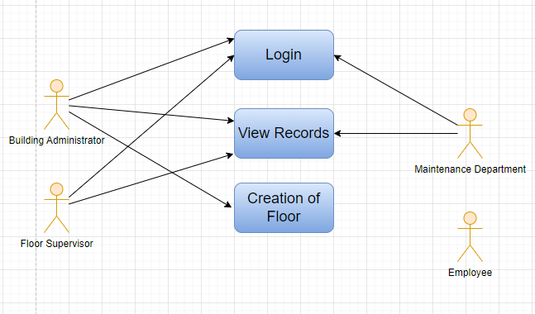

### Design of Workflow

* Design workflow is not applicable to this screen as records in this are created by only one role and are not sent to users with other roles for approval or modification.

### Validations

**Client Side Validation:**

Client-side validation refers to the process of validating user input directly on the client's web browser before saving it to the server for further processing.

The following validations are done on client side for Floor Screen:

* Mandatory checks for fields : Building Name, Floor Number, Number of rooms, Item Code, Custodian, Department
* Linked fields : The Building Name field is linked with the Building Screen. The Item Code field is linked with the Item Screen. The Custodian field is linked with the Employee Screen. The Department field is linked with the Department Screen.

**Server Side Validation:**

Server-side validation refers to the process of validating user input on the server to ensure data integrity, security, and adherence to business rules before accepting or processing the information.

There are no server side validations for the Floor screen

**Notification:**

* This section is not applicable since there is no notifications to be triggered

### Field List:

|  |  |  |  |  |  |
| --- | --- | --- | --- | --- | --- |
| **ID** | **Field Label** | **Field Type** | **Validation/Action** | **Mandatory** | **Remarks** |
| 1 | Building Name | Link Field | Fetched from Building master screen | Y |  |
| 2 | Floor Number | Text Field |  | Y |  |
| 3 | Floor Size | Integer Field |  |  |  |
| 4 | Number of rooms | Text Field |  | Y |  |
| 5 | Floor Plan | Attach |  |  |  |
| 6 | Floor Incharge | Text Field |  |  |  |
| **7** | **Floor Assets** | Table |  |  |  |
| **8** | **Floor Documents** | Table |  |  |  |

|  |  |  |  |  |  |
| --- | --- | --- | --- | --- | --- |
| **Floor Assets** | | | | | |
| **ID** | **Field Label** | **Field Type** | **Validation/Action** | **Mandatory** | **Remarks** |
| 1 | Item Code | Link Field | Fetched from Item master screen | Y |  |
| 2 | Item Name | Text Field | Auto fetch based on Item Code |  |  |
| 3 | Location | Link Field | Fetched from Location master screen |  |  |
| 4 | Asset Name | Text Field | User Input |  |  |
| 5 | Custodian | Link Field | Fetched from Employee master screen | Y |  |
| 6 | Department | Link Field | Fetched from Department screen | Y |  |

|  |  |  |  |  |  |
| --- | --- | --- | --- | --- | --- |
| **Floor Documents** | | | | | |
| **ID** | **Field Label** | **Field Type** | **Validation/Action** | **Mandatory** | **Remarks** |
| 1 | Document Name | Text Field | User Input |  |  |
| 2 | Attachment | Attach Button |  |  |  |

### Processes After Form Submission

* This section is not applicable since the form has no workflow based on submission.

### Process Flow:

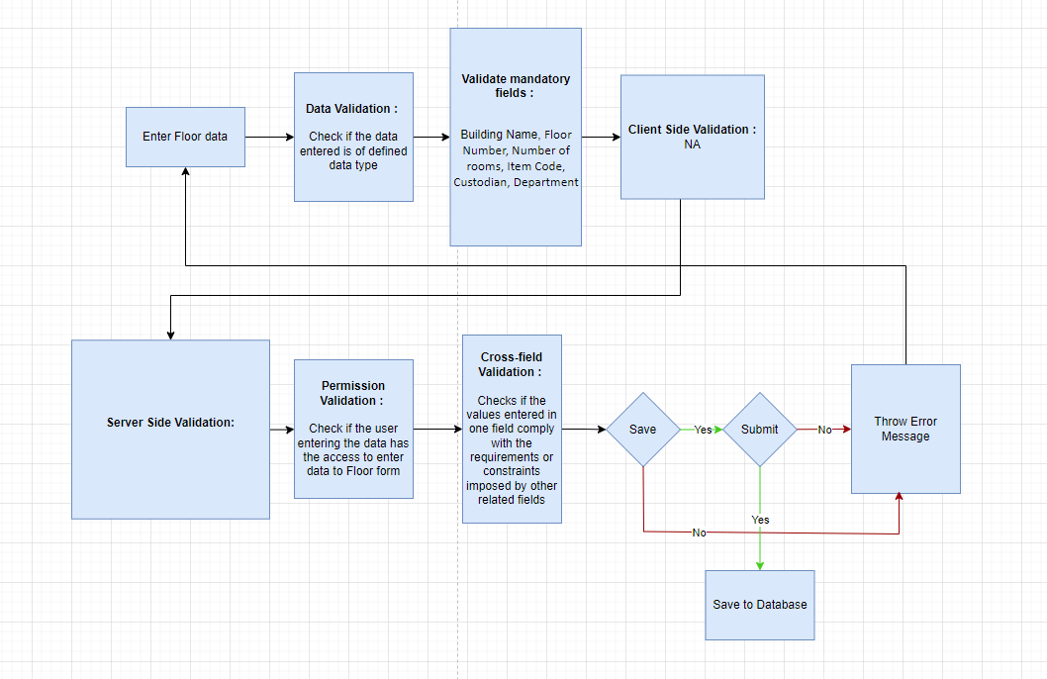

### Pre-requisites and Dependency

* Building

## Building Room

**This is a master screen, in which we shall be storing the building’s room details and classifying the rooms. This screen also help us assign a number to the residence ( For e.g, Residence number).**

**The operations on this screen can be performed by the Administrator only.**

**In this screen, the user shall select the type of room and, based on selection, the type of residence shall be fetched.**

**Further on selection of type of residence, the residence type name(e.g. 2BHK) drop down shall be fetched.**

### Use Case Diagram

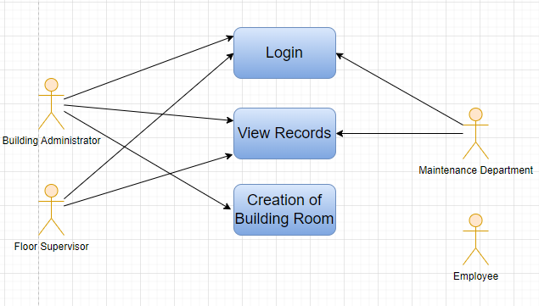

### Design of Workflow

* Design workflow is not applicable to this screen as records in this are created by only one role and are not sent to users with other roles for approval or modification.

### Validations

**Client Side Validation:**

Client-side validation refers to the process of validating user input directly on the client's web browser before saving it to the server for further processing.

The following validations are done on client side for Building Room Screen:

* Mandatory checks for fields : Building Address, Building's Land Plot number, Building's Land Address, District, State, Pin Code, Room No., Type of Room, Item Code**,** Custodian, Department.
* Linked fields : The Building Name field is linked with the Building Screen. The Type of Room field is linked with the Building type Room Screen. The Item Code field is linked with the Item Screen. The Custodian field is linked with the Employee Screen. The Department field is linked with the Department Screen.

**Server Side Validation:**

Server-side validation refers to the process of validating user input on the server to ensure data integrity, security, and adherence to business rules before accepting or processing the information.

Following are the server side validations in the Building Room screen:

* duplicate(self) : This definition is used to check for any duplicate record within a building regarding room number or room type
* dateValidate(self) : This definition is used to validated if the start date is not after the end date in allotable room type
* new_doc(self) : This definition is used to create new record in Room doctype if the record made in Building Room is scheduled and is a new record

**Notification:**

* This section is not applicable since there is no notifications to be triggered

### Field List:

|  |  |  |  |  |  |
| --- | --- | --- | --- | --- | --- |
| **ID** | **Field Label** | **Field Type** | **Validation/Action** | **Mandatory** | **Remarks** |
| 1 | Building Name | Link Field | Fetched from Building master screen |  |  |
| 2 | Building Type | Text Field | Auto fetch based on Building Name |  |  |
| 3 | Building Address | Text Field | Auto fetch based on Building Name | Y |  |
| 4 | Building's Land Plot number | Text Field | Auto fetch based on Building Name | Y |  |
| 5 | Building's Land Address | Text Field | Auto fetch based on Building Name | Y |  |
| 6 | District | Text Field | Auto fetch based on Building Name | Y |  |
| 7 | State | Text Field | Auto fetch based on Building Name | Y |  |
| 8 | Pin Code | Text Field | Auto fetch based on Building Name | Y |  |
| 9 | Room No. | Text Field |  | Y |  |
| 10 | Floor | Text Field | Ground  1 ….. |  |  |
| 11 | Type of Room | Link Field | Building type Room | Y |  |
| 12 | **Room Assets** | Table |  |  |  |

|  |  |  |  |  |  |
| --- | --- | --- | --- | --- | --- |
| **Room Assets** | | | | | |
| **ID** | **Field Label** | **Field Type** | **Validation/Action** | **Mandatory** | **Remarks** |
| 1 | Item Code | Link Field | Fetched from Item master screen | Y |  |
| 2 | Item Name | Text Field | Auto fetch based on Item Code |  |  |
| 3 | Location | Link Field | Fetched from Location master screen |  |  |
| 4 | Asset Name | Text Field | User Input |  |  |
| 5 | Custodian | Link Field | Fetched from Employee master screen | Y |  |
| 6 | Department | Link Field | Fetched from Department screen | Y |  |

### Processes After Form Submission

* This section is not applicable since the form is not submittable.

### Process Flow:

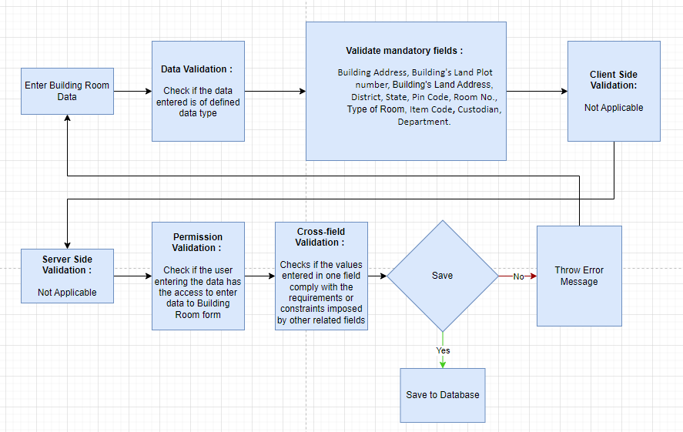

### Pre-requisites and Dependency

* Building

## Building Type Room

**This screen helps define the type of the room, for example if it is a classroom or residential or conference hall. The operations on this screen can be performed by the Administrator only.**

### Use Case Diagram

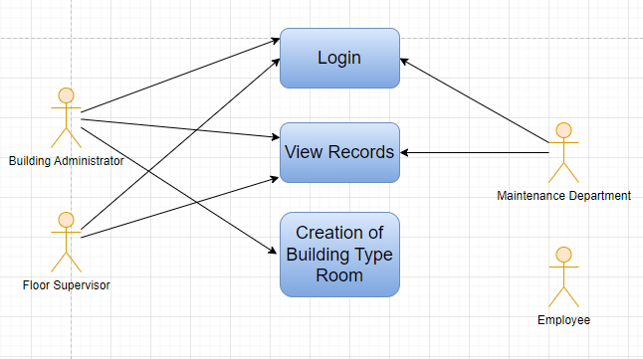

### Design of Workflow

* Design workflow is not applicable to this screen as records in this are created by only one role and are not sent to users with other roles for approval or modification.

### Validations

**Client Side Validation:**

Client-side validation refers to the process of validating user input directly on the client's web browser before saving it to the server for further processing.

The following validations are done on client side for Building Type Room Screen:

* Mandatory checks for fields : Type of Room, Allotment Status

**Server Side Validation:**

Server-side validation refers to the process of validating user input on the server to ensure data integrity, security, and adherence to business rules before accepting or processing the information.

No server side validation is done for Building Type Room Screen.

**Notification:**

* This section is not applicable since there is no notifications to be triggered

### Field List:

|  |  |  |  |  |  |
| --- | --- | --- | --- | --- | --- |
| **ID** | **Field Label** | **Field Type** | **Validation/Action** | **Mandatory** | **Remarks** |
| 1 | Type of Room | Text Field | User Input | Y |  |
| 2 | Allotment Status | Drop down | Allottable  Non Allottable | Y |  |

### Processes After Form Submission

* Not Applicable

### Process Flow:

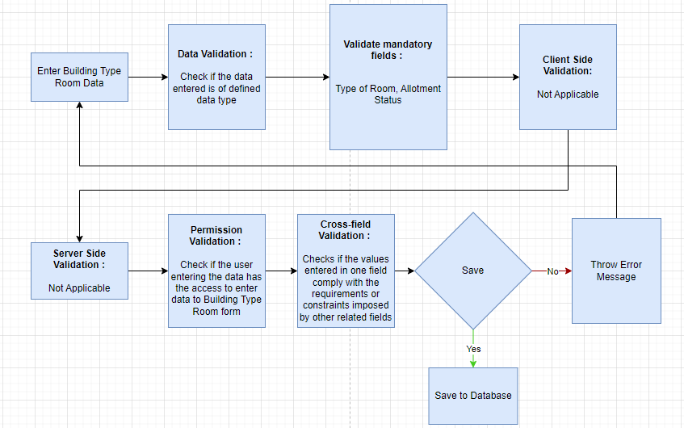

### Pre-requisites and Dependency

* Not Applicable

## Asset

In Asset, you can maintain fixed asset records for company assets like computers, furniture, cars, etc. and manage their depreciation, sale, or disposal. You can track locations of the assets or keep records of employees who are using the asset. You can also manage the maintenance details of the assets.

### Use Case Diagram

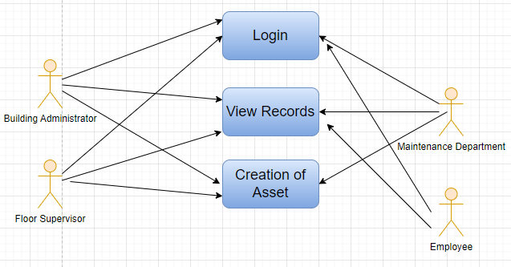

### Design of Workflow

* Design workflow is not applicable to this screen as records in this are created by only three roles and are not sent to users with other roles for approval or modification.

### Validations

**Client Side Validation:**

Client-side validation refers to the process of validating user input directly on the client's web browser before saving it to the server for further processing.

The following validations are done on client side for Asset Screen:

* Mandatory checks for fields : Company, Item Code, Asset Name, Location, Available-for-use Date, Gross Purchase Amount, Purchase Date
* Linked fields : The Company field is linked with the Company Screen. The Item Code field is linked with the Item Screen.

**Server Side Validation:**

* validate_asset_and_reference(self) - This definition validates whether the company of asset and the purchase document matches
* prepare_deprecation_data(self, date_of_disposal=None, date_of_return=None) - This definition takes date_of_disposal and date_of_return as parameters and establish the depreciation rate, depreciation schedule and also set the accumulated depreciation
* validate_item(self) - This definition validates whether the item is disabled, is fixed asset item, is non-stock item and throws error messages accordingly
* validate_cost_center(self) - This definition validates the cost center and ensures that the correct cost center is displayed on the screen

**Notification:**

* This section is not applicable since there is no notifications to be triggered

### Field List:

|  |  |  |  |  |  |  |
| --- | --- | --- | --- | --- | --- | --- |
| **ID** | **Field Label** | **Field Type** | **Validation/ Action** | **Mandatory** | **Remarks** | **R/N/D** |
| 1 | Company | Link | Fetched from Company screen | Yes |  |  |
| 2 | Item Code | Link | Fetched from Item screen | Yes |  |  |
| 3 | Item Name | Read Only | Populated based on selection of Item code |  |  |  |
| 4 | Asset Owner | Dropdown | Company/  Supplier /  Customer |  |  |  |
| 5 | Asset Owner Company | Link | Fetched from Company screen |  |  |  |
| 6 | Is Existing Asset | Checkbox | User Input |  |  |  |
| 7 | Supplier | Link | Fetched from Supplier screen |  |  |  |
| 8 | Customer | Link | Fetched from Customer screen |  |  |  |
| 9 | Image | Attach Image | User Input |  |  |  |
| 10 | Naming Series | Dropdown | ACC-ASS-.YYYY.- |  |  |  |
| 11 | Asset Name | Text Field | User Input | Yes |  |  |
| 12 | Asset Category | Link | Fetched from Asset Category screen |  |  |  |
| 13 | Location | Link | Fetched from Location screen | Yes |  |  |
| 14 | Custodian | Link | Fetched from Employee screen |  |  |  |
| 15 | Department | Link | Fetched from Department screen |  |  |  |
| 16 | Disposal Date | Date | User Input |  |  |  |
| 17 | Address | Link | Fetched from Address screen |  |  |  |
| 18 | Cost Center | Link | Fetched from Cost Center screen |  |  |  |
| 19 | Purchase Receipt | Link | Fetched from Purchase Invoice screen |  |  |  |
| 20 | Purchase Invoice | Link | Fetched from Purchase Invoice screen |  |  |  |
| 21 | Available-for-use Date | Date | User Input | Yes |  |  |
| 22 | Gross Purchase Amount | Currency | User Input | Yes |  |  |
| 23 | Asset Quantity | Int | User Input |  |  |  |
| 24 | Purchase Date | Date | User Input | Yes |  |  |
| 25 | Calculate Depreciation | Checkbox | User Input |  |  |  |
| 26 | Opening Accumulated Depreciation | Currency | User Input |  |  |  |
| 27 | Number of Depreciation's Booked | Int | User Input |  |  |  |
| 28 | **Finance Books** | Table | These table is describe below |  |  |  |
| 29 | Depreciation Method | Dropdown | Straight Line /  Double Declining Balance /  Manual |  |  |  |
| 30 | Value After Depreciation | Currency | User Input |  |  |  |
| 31 | Total Number of Depreciation's | Int | User Input |  |  |  |
| 32 | Frequency of Depreciation (Months) | Int | User Input |  |  |  |
| 33 | Next Depreciation Date | Date | User Input |  |  |  |
| 34 | **Depreciation Schedule** | Table | These table is describe below |  |  |  |
| 35 | Policy number | Text Field | User Input |  |  |  |
| 36 | Insurer | Text Field | User Input |  |  |  |
| 37 | Insured value | Text Field | User Input |  |  |  |
| 38 | Insurance Start Date | Date | User Input |  |  |  |
| 39 | Insurance End Date | Date | User Input |  |  |  |
| 40 | Comprehensive Insurance | Text Field | User Input |  |  |  |
| 41 | Maintenance Required | Checkbox | User Input |  |  |  |
| 42 | Status | Dropdown | Draft /  Submitted /  Partially Depreciated /  Fully Depreciated /  Sold /  Scrapped /  In Maintenance /  Out of Order /  Issue /  Receipt /  Capitalized /  Decapitalized |  |  |  |
| 43 | Booked Fixed Asset | Checkbox | User Input |  |  |  |
| 44 | Purchase Receipt Amount | Currency | User Input |  |  |  |
| 45 | Default Finance Book | Link | Fetched from Finance Book screen |  |  |  |
| 46 | Depreciation Entry Posting Status | Dropdown | Successful /  Failed |  |  |  |
| 47 | Manage | Button | Transfer Asset: On click of this button you can transfer Asset from One employee/Location to another |  |  |  |
| Scrap Asset: On click of this button you can scrap Asset |  |  |  |
| Sell Asset: On click of this button you can sell Asset |  |  |  |
| Maintain Asset: On click of this button you can create Maintenance schedule for an Asset |  |  |  |
| Repair Asset: On click of this button you can create repair details for an Asset |  |  |  |
| Split Asset: On click of this you can split Asset |  |  |  |
| Adjust Asset value: On click of this button you can see the value of Asset |  |  |  |
| View Ledger Entry: On click of this button you can view General entry for the Asset |  |  |  |

|  |  |  |  |  |  |  |
| --- | --- | --- | --- | --- | --- | --- |
| **Finance Books** | | | | | | |
| **ID** | **Field Label** | **Field Type** | **Validation/ Action** | **Mandatory** | **Remarks** | **R/N/D** |
| 1 | Finance Book | Link | Fetched from Finance book screen |  |  |  |
| 2 | Depreciation Method | Dropdown | Straight Line /  Double Declining Balance /  Written Down Value /  Manual | Yes |  |  |
| 3 | Total Number of Depreciation | Int | User Input | Yes |  |  |
| 4 | Frequency of Depreciation (Months) | Int | User Input | Yes |  |  |
| 5 | Depreciation Posting Date | Date | User Input |  |  |  |
| 6 | Expected Value After Useful Life | Currency | User Input |  |  |  |
| 7 | Value After Depreciation | Currency | User Input |  |  |  |
| 8 | Rate of Depreciation | Percent | User Input |  |  |  |

|  |  |  |  |  |  |  |
| --- | --- | --- | --- | --- | --- | --- |
| **Depreciation Schedule** | | | | | | |
| **ID** | **Field Label** | **Field Type** | **Validation/ Action** | **Mandatory** | **Remarks** | **R/N/D** |
| 1 | Finance Book | Link | Fetched from Finance book screen |  |  |  |
| 2 | Schedule Date | Date | User Input | Yes |  |  |
| 3 | Depreciation Amount | Currency | User Input | Yes |  |  |
| 4 | Accumulated Depreciation Amount | Currency | User Input |  |  |  |
| 5 | Journal Entry | Link | Fetched from Finance book screen |  |  |  |
| 6 | Make Depreciation Entry | Button | On click of this button make depreciation entry for Asset |  |  |  |
| 7 | Finance Book Id | Text Field | User Input |  |  |  |
| 8 | Depreciation Method | DropDown | User Input |  |  |  |

### Processes After Form Submission

* This section is not applicable since the form has no workflow based on submission.

### 

### Process Flow:

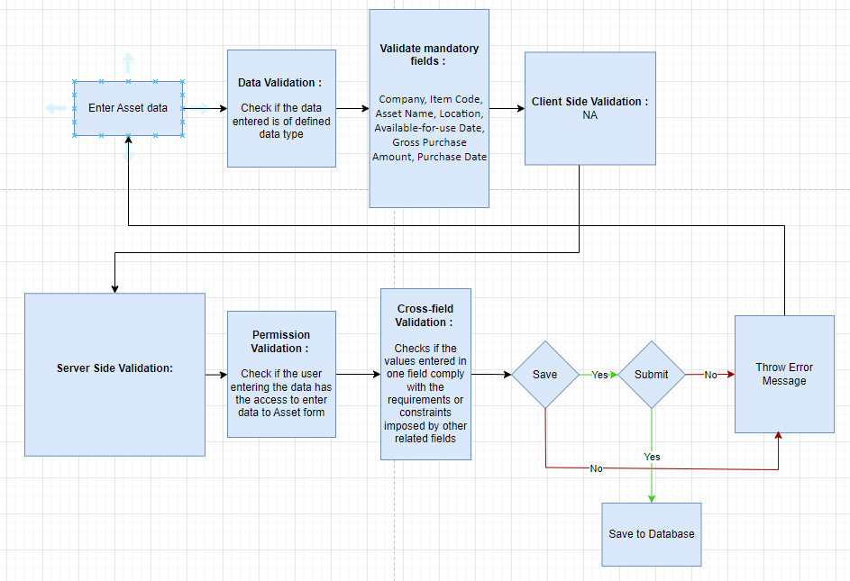

### Pre-requisites and Dependency

* Company
* Item

## Asset Maintenance Team

The Asset Maintenance Team is responsible for carrying out maintenance activities on the Asset.

### Use Case Diagram

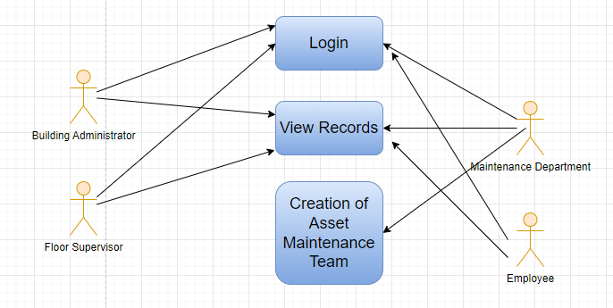

### Design of Workflow

* Design workflow is not applicable to this screen as records in this are created by only one role and are not sent to users with other roles for approval or modification.

### Validations

**Client Side Validation:**

Client-side validation refers to the process of validating user input directly on the client's web browser before saving it to the server for further processing.

The following validations are done on client side for Asset Maintenance Team Screen:

* Mandatory checks for fields : Maintenance Team Name, Company, Maintenance Team Members
* Linked fields : The Maintenance Manager field is linked with the User Screen. The Company field is linked with the Company Screen.

**Server Side Validation:**

Server-side validation refers to the process of validating user input on the server to ensure data integrity, security, and adherence to business rules before accepting or processing the information.

No server side validation is done for Asset Maintenance Team Screen.

**Notification:**

* This section is not applicable since there is no notifications to be triggered

### Field List:

|  |  |  |  |  |  |  |
| --- | --- | --- | --- | --- | --- | --- |
| **ID** | **Field Label** | **Field Type** | **Validation/ Action** | **Mandatory** | **Remarks** | **R/N/D** |
| 1 | Maintenance Team Name | Text Field | User Input | Yes |  |  |
| 2 | Maintenance Manager | Link | Fetched from User screen |  |  |  |
| 3 | Maintenance Manager Name | Read Only | Fetched through Maintenance Manager |  |  |  |
| 4 | Company | Link | Fetched from Company screen | Yes |  |  |
| **5** | **Maintenance Team Members** | **Table** |  | Yes | These table is describe below |  |

|  |  |  |  |  |  |  |  |
| --- | --- | --- | --- | --- | --- | --- | --- |
| **Maintenance Team Members** | | | | | | | |
| **ID** | **Field Label** | **Field Type** | **Validation/ Action** | **Mandatory** | **Remarks** | | **R/N/D** |
| 1 | Team Member | Link | Fetched from User screen | Yes |  |  | |
| 2 | Full Name | Text Field | User Input |  |  |  | |
| 3 | Maintenance Role | Link | Fetched from Role screen | Yes |  |  | |
|  | Is External | Checkbox | When checked, the below fields will appear |  |  |  | |
|  | Maintenance Member Name | Text Field |  |  |  |  | |
|  | Contact Number | Text Field |  |  |  |  | |
|  | Company | Text Field |  |  |  |  | |

### Processes After Form Submission

* This section is not applicable since the form is not submittable.

### 

### Process Flow:

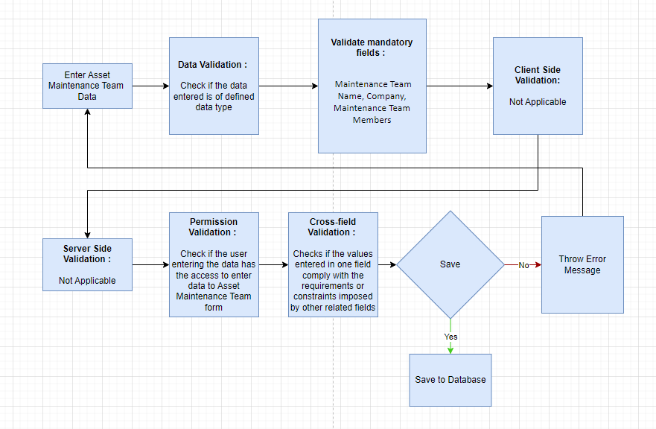

### Pre-requisites and Dependency

* Company

## Asset Maintenance

Asset Maintenance refers to any activity done on Assets to maintain their performance or condition.

### Use Case Diagram

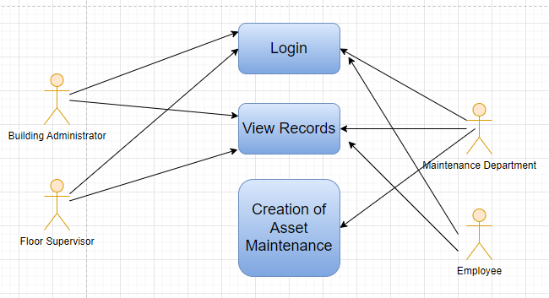

### Design of Workflow

* Design workflow is not applicable to this screen as records in this are created by only one role and are not sent to users with other roles for approval or modification.

### Validations

**Client Side Validation:**

Client-side validation refers to the process of validating user input directly on the client's web browser before saving it to the server for further processing.

The following validations are done on client side for Asset Maintenance Screen:

* Mandatory checks for fields : Asset Name, Company, Maintenance Team, Maintenance Tasks
* Linked fields : The Company field is linked with the Company Screen. The Asset Name field is linked with the Asset Screen. The Maintenance Team field is linked with the Asset Maintenance Team Screen.

**Server Side Validation:**

Server-side validation refers to the process of validating user input on the server to ensure data integrity, security, and adherence to business rules before accepting or processing the information.

No server side validation is done for Asset Maintenance Screen.

**Notification:**

* This section is not applicable since there is no notifications to be triggered

### Field List:

|  |  |  |  |  |  |  |
| --- | --- | --- | --- | --- | --- | --- |
| **ID** | **Field Label** | **Field Type** | **Validation/ Action** | **Mandatory** | **Remarks** | **R/N/D** |
| 1 | Asset Name | Link | Fetched from Asset screen | Yes |  |  |
| 2 | Asset Category | Read Only | Fetched from selected asset |  |  |  |
| 3 | Company | Link | Fetched from Company screen | Yes |  |  |
| 4 | Item Code | Read Only | Fetched from selected asset |  |  |  |
| 5 | Item Name | Read Only | Fetched from selected asset |  |  |  |
| 6 | Maintenance Team | Link | Fetched from Asset Maintenance Team screen | Yes |  |  |
| 7 | Maintenance Manager | Text Field | User Input |  |  |  |
| 8 | Maintenance Manager Name | Read Only | Fetched from selected Asset Maintenance Team |  |  |  |
| 9 | **Maintenance Tasks** | **Table** |  | **Yes** | These table is describe below |  |

|  |  |  |  |  |  |  |
| --- | --- | --- | --- | --- | --- | --- |
| **Maintenance Task** | | | | | | |
| **ID** | **Field Label** | **Field Type** | **Validation/ Action** | **Mandatory** | **Remarks** | **R/N/D** |
| 1 | Maintenance Task | Text Field | User Input | Yes |  |  |
| 2 | Maintenance Type | Select | Preventive Maintenance /  Calibration |  |  |  |
| 3 | Maintenance Status | Select | Planned / Overdue / Canceled | Yes |  |  |
| 4 | Start Date | Text Field | User Input | Yes |  |  |
| 5 | Periodicity | Select | Once  Daily / Weekly / Monthly /  Quarterly / Yearly / 2 Yearly | Yes |  |  |
| 6 | End Date | Date | User Input |  |  |  |
| 7 | Certificate Required | Checkbox | User Input |  |  |  |
| 8 | Assign To | Link | Fetched from User screen |  |  |  |
| 9 | Assign to Name | Read Only | Feted from value selected from Assign to value |  |  |  |
| 10 | Next Due Date | Date | User Input |  |  |  |
| 11 | Last Completion Date | Date | User Input |  |  |  |
| 12 | Description | Text Editor | User Input |  |  |  |

### Processes After Form Submission

* This section is not applicable since the form is not submittable.

### Process Flow:

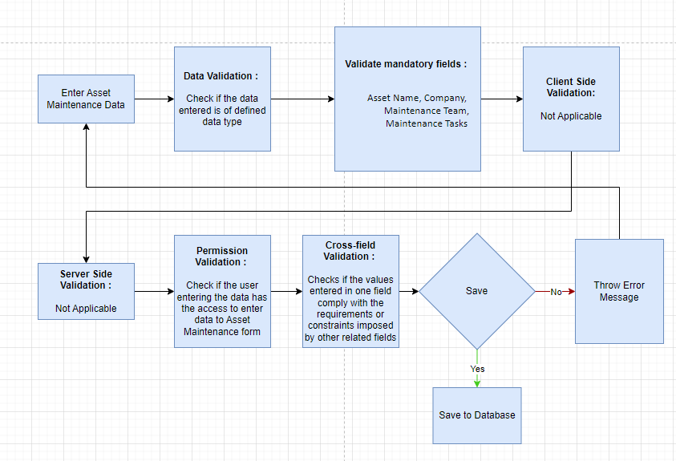

### Pre-requisites and Dependency

* Asset
* Asset Maintenance Team
* Company

## Asset Maintenance Log

Asset Maintenance Log logs the tasks carried out in an Asset Maintenance.

### Use Case Diagram

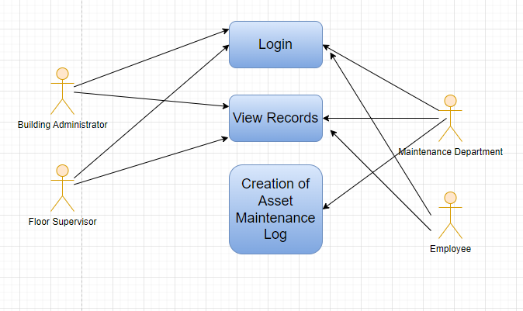

### Design of Workflow

* Design workflow is not applicable to this screen as records in this are created by only one role and are not sent to users with other roles for approval or modification.

### Validations

**Client Side Validation:**

Client-side validation refers to the process of validating user input directly on the client's web browser before saving it to the server for further processing.

The following validations are done on client side for Asset Maintenance Log Screen:

* Mandatory checks for fields : Maintenance Status
* Linked fields : The Asset Maintenance field is linked with the Asset Maintenance Screen.

**Server Side Validation:**

Server-side validation refers to the process of validating user input on the server to ensure data integrity, security, and adherence to business rules before accepting or processing the information.

No server side validation is done for Asset Maintenance Log Screen.

**Notification:**

* This section is not applicable since there is no notifications to be triggered

### Field List:

|  |  |  |  |  |  |  |
| --- | --- | --- | --- | --- | --- | --- |
| **ID** | **Field Label** | **Field Type** | **Validation/ Action** | **Mandatory** | **Remarks** | **R/N/D** |
| 1 | Asset Maintenance | Link | Fetched from Asset Maintenance screen |  |  |  |
| 2 | Series | Dropdown | ACC-AML-.YYYY.- | Yes |  |  |
| 3 | Asset Name | Read Only | Fetched from Asset Maintenance asset |  |  |  |
| 4 | Item Code | Read Only | Fetched from Asset Maintenance asset |  |  |  |
| 5 | Item Name | Read Only | Fetched from Asset Maintenance asset |  |  |  |
| 6 | Task | Link | Fetched from Task screen |  |  |  |
| 7 | Task Name | Text Field | User Input |  |  |  |
| 8 | Maintenance Type | Read Only | Fetched from Task asset |  |  |  |
| 9 | Periodicity | Text Field | User Input |  |  |  |
| 10 | Has Certificate | Checkbox | User Input |  |  |  |
| 11 | Certificate | Attach | User Input |  |  |  |
| 12 | Maintenance Status | Dropdown | Planned/ Completed /  Cancelled / Overdue | Yes |  |  |
| 13 | Assign To | Read Only | Fetched from Task asset |  |  |  |
| 14 | Due Date | Date | User Input |  |  |  |
| 15 | Completion Date | Date | User Input |  |  |  |
| 16 | Description | Read Only | Fetched from Task asset |  |  |  |
| 17 | Actions performed | Text Editor | User Input |  |  |  |

### 

### Processes After Form Submission

* This section is not applicable since the form has no workflow based on submission.

### Process Flow:

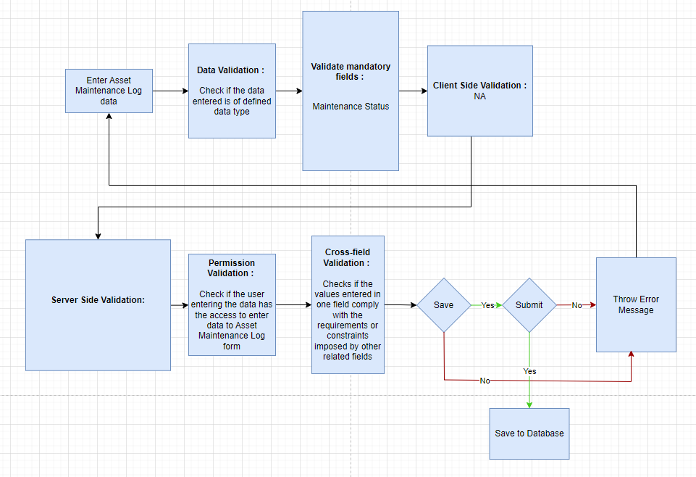

### Pre-requisites and Dependency

* Asset Maintenance

## Asset Repair

Asset Repair refers to any activity carried to repair a broken Asset to restore full functionality.

### Use Case Diagram

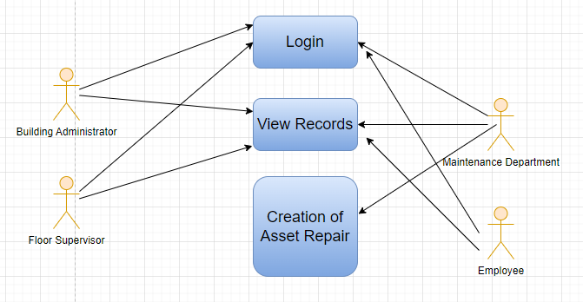

### Design of Workflow

* Design workflow is not applicable to this screen as records in this are created by only one role and are not sent to users with other roles for approval or modification.

### Validations

**Client Side Validation:**

Client-side validation refers to the process of validating user input directly on the client's web browser before saving it to the server for further processing.

The following validations are done on client side for Asset Repair Screen:

* Mandatory checks for fields : Asset, Company, Failure Date
* Linked fields : The Asset field is linked with the Asset Maintenance Screen. The Company field is linked with the Company Screen.

**Server Side Validation:**

Server-side validation refers to the process of validating user input on the server to ensure data integrity, security, and adherence to business rules before accepting or processing the information.

No server side validation is done for Asset Repair Screen.

**Notification:**

* This section is not applicable since there is no notifications to be triggered

### Field List:

|  |  |  |  |  |  |  |
| --- | --- | --- | --- | --- | --- | --- |
| **ID** | **Field Label** | **Field Type** | **Validation/ Action** | **Mandatory** | **Remarks** | **R/N/D** |
| 1 | Asset | Link | Fetched from Asset Maintenance screen | Yes |  |  |
| 2 | Company | Link | Fetched from Asset Maintenance screen |  |  |  |
| 3 | Asset Name | Read Only | Fetched from value in Asset field |  |  |  |
| 4 | Series | Dropdown | ACC-ASR-.YYYY.- | Yes |  |  |
| 5 | Failure Date | Datetime | User Input | Yes |  |  |
| 6 | Repair Status | Dropdown | Pending / completed /Cancelled |  |  |  |
| 7 | Completion Date | Datetime | User Input |  |  |  |
| 8 | Address | Link | Fetched from Address screen |  |  |  |
| 9 | Article | Link | Fetched from Article screen |  |  |  |
| 10 | Cost Center | Link | Fetched from Cost center screen |  |  |  |
| 11 | Project | Link | Fetched from Project screen |  |  |  |
| 12 | Repair Cost | Currency | User Input |  |  |  |
| 13 | Capitalize Repair Cost | Checkbox | User Input |  |  |  |
| 14 | Stock Consumed During Repair | Checkbox | User Input |  |  |  |
| 15 | Purchase Invoice | Link | Fetched from Purchase Invoice screen |  |  |  |
| 16 | Warehouse | Link | Fetched from Warehouse screen |  |  |  |
| 17 | **Stock Items** | Table |  |  | These table is describe below |  |
| 18 | Total Repair Cost | Currency | User Input |  |  |  |
| 19 | Stock Entry | Link | Fetched from Stock Entry screen |  |  |  |
| 20 | Increase In Asset Life(Months) | Int | User Input |  |  |  |
| 21 | Error Description | Long Text | User Input |  |  |  |
| 22 | Actions performed | Long Text | User Input |  |  |  |
| 23 | Downtime | Text Field | User Input |  |  |  |
| 24 | View General Ledger | Button | On click of the button you can General ledger for the Asset repair |  |  |  |

|  |  |  |  |  |  |  |
| --- | --- | --- | --- | --- | --- | --- |
| **Stock Items (Child Table)** | | | | | | |
| **ID** | **Field Label** | **Field Type** | **Validation/ Action** | **Mandatory** | **Remarks** | **R/N/D** |
| 1 | Item | Link | Fetched from Item screen |  |  |  |
| 2 | Valuation Rate | Currency | User Input |  |  |  |
| 3 | Consumed Quantity | Text Field | User Input |  |  |  |
| 4 | Total Value | Currency | User Input |  |  |  |
| 5 | Serial No | Small Text | User Input |  |  |  |

### Processes After Form Submission

* This section is not applicable since the form has no workflow based on submission.

### Process Flow:

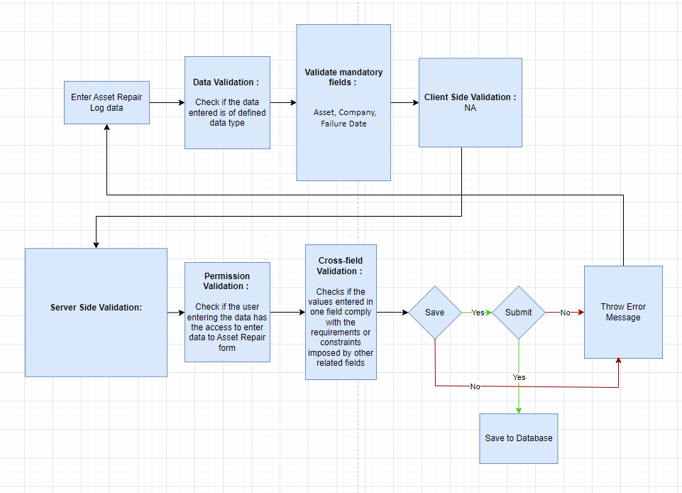

### Pre-requisites and Dependency

* Asset

# Tools And Technologies

This section explains the tools that are used to build this design document

* Draw.io - it is an online tool used to develop the flowcharts used in this document.
* WPS office - it is a text editor that has been used to write and assemble this document

# Non-Functional Requirements

## Performance

Specify performance requirements, including response times, transaction throughput, and system scalability

## Reliability

Define the reliability requirements, such as availability, fault tolerance, and disaster recovery

## Usability

Describe usability requirements, including user-friendly interfaces, clear error messages, and intuitive workflows

## Compatibility

Specify compatibility requirements with different operating systems, web browsers, and devices

## Security

Security requirements, including authentication, access control, data encryption, and secure communication protocols

## Compliance

Specify any legal or regulatory compliance requirements, such as GDPR, PCI DSS, or other industry-specific standards

## Documentation

Describe the documentation requirements, including user manuals, developer guides, and API documentation

## Security: User access and authorization

The screens and the data in them is made secure by creating roles with different permissions and then assigning those roles the appropriate users. For this screen following are the roles and their corresponding permissions:

### 

**Land**

|  |  |  |  |  |  |  |  |  |  |  |
| --- | --- | --- | --- | --- | --- | --- | --- | --- | --- | --- |
| **ID** | | **Role** | **Select** | **Read** | **Write** | **Create** | **Delete** | **Submit** | **Cancel** | **Amend** |
| 1 | Building Administrator | | Yes | Yes | Yes | Yes | Yes | NA | NA | NA |
| 2 | Floor Supervisor | | No | Yes | No | No | No | NA | NA | NA |
| 3 | Maintenance Department | | No | Yes | No | No | No | NA | NA | NA |
| 4 | Employee | | No | No | No | No | No | No | No | No |

**Building**

|  |  |  |  |  |  |  |  |  |  |
| --- | --- | --- | --- | --- | --- | --- | --- | --- | --- |
| **ID** | **Role** | **Select** | **Read** | **Write** | **Create** | **Delete** | **Submit** | **Cancel** | **Amend** |
| 1 | Building Administrator | Yes | Yes | Yes | Yes | Yes | NA | NA | NA |
| 2 | Floor Supervisor | No | Yes | No | No | No | NA | NA | NA |
| 3 | Maintenance Department | No | Yes | No | No | No | NA | NA | NA |
| 4 | Employee | No | No | No | No | No | NA | NA | NA |

**Floor**

|  |  |  |  |  |  |  |  |  |  |  |
| --- | --- | --- | --- | --- | --- | --- | --- | --- | --- | --- |
| **ID** | | **Role** | **Select** | **Read** | **Write** | **Create** | **Delete** | **Submit** | **Cancel** | **Amend** |
| 1 | Building Administrator | | Yes | Yes | Yes | Yes | Yes | NA | NA | NA |
| 2 | Floor Supervisor | | No | Yes | No | No | No | NA | NA | NA |
| 3 | Maintenance Department | | No | Yes | No | No | No | NA | NA | NA |
| 4 | Employee | | No | No | No | No | No | NA | NA | NA |

### 

**Building Room**

|  |  |  |  |  |  |  |  |  |  |
| --- | --- | --- | --- | --- | --- | --- | --- | --- | --- |
| **ID** | **Role** | **Select** | **Read** | **Write** | **Create** | **Delete** | **Submit** | **Cancel** | **Amend** |
| 1 | Building Administrator | Yes | Yes | Yes | Yes | Yes | NA | NA | NA |
| 2 | Floor Supervisor | No | Yes | No | No | No | NA | NA | NA |
| 3 | Maintenance Department | No | Yes | No | No | No | NA | NA | NA |
| 4 | Employee | No | No | No | No | No | NA | NA | NA |

**Building Type Room**

|  |  |  |  |  |  |  |  |  |  |  |
| --- | --- | --- | --- | --- | --- | --- | --- | --- | --- | --- |
| **ID** | | **Role** | **Select** | **Read** | **Write** | **Create** | **Delete** | **Submit** | **Cancel** | **Amend** |
| 1 | Building Administrator | | Yes | Yes | Yes | Yes | Yes | NA | NA | NA |
| 2 | Floor Supervisor | | No | Yes | No | No | No | NA | NA | NA |
| 3 | Maintenance Department | | No | Yes | No | No | No | NA | NA | NA |
| 4 | Employee | | No | No | No | No | No | NA | NA | NA |

**Asset**

|  |  |  |  |  |  |  |  |  |  |
| --- | --- | --- | --- | --- | --- | --- | --- | --- | --- |
| **ID** | **Role** | **Select** | **Read** | **Write** | **Create** | **Delete** | **Submit** | **Cancel** | **Amend** |
|  | Building Administrator | Yes | Yes | Yes | Yes | Yes | Yes | Yes | Yes |
|  | Floor Supervisor | Yes | Yes | Yes | Yes | Yes | Yes | Yes | Yes |
|  | Maintenance Department | Yes | Yes | Yes | Yes | Yes | Yes | Yes | Yes |
|  | Employee | Yes | Yes | No | No | No | No | No | No |

**Asset Maintenance Team**

|  |  |  |  |  |  |  |  |  |  |
| --- | --- | --- | --- | --- | --- | --- | --- | --- | --- |
| **ID** | **Role** | **Select** | **Read** | **Write** | **Create** | **Delete** | **Submit** | **Cancel** | **Amend** |
|  | Building Administrator | No | Yes | No | No | No | No | No | No |
|  | Floor Supervisor | No | Yes | No | No | No | No | No | No |
|  | Maintenance Department | Yes | Yes | Yes | Yes | Yes | Yes | Yes | Yes |
|  | Employee | No | Yes | No | No | No | No | No | No |

**Asset Maintenance**

|  |  |  |  |  |  |  |  |  |  |
| --- | --- | --- | --- | --- | --- | --- | --- | --- | --- |
| **ID** | **Role** | **Select** | **Read** | **Write** | **Create** | **Delete** | **Submit** | **Cancel** | **Amend** |
|  | Building Administrator | No | Yes | No | No | No | No | No | No |
|  | Floor Supervisor | No | Yes | No | No | No | No | No | No |
|  | Maintenance Department | Yes | Yes | Yes | Yes | Yes | Yes | Yes | Yes |
|  | Employee | No | Yes | No | No | No | No | No | No |

**Asset Maintenance Log**

|  |  |  |  |  |  |  |  |  |  |
| --- | --- | --- | --- | --- | --- | --- | --- | --- | --- |
| **ID** | **Role** | **Select** | **Read** | **Write** | **Create** | **Delete** | **Submit** | **Cancel** | **Amend** |
|  | Building Administrator | No | Yes | No | No | No | No | No | No |
|  | Floor Supervisor | No | Yes | No | No | No | No | No | No |
|  | Maintenance Department | Yes | Yes | Yes | Yes | Yes | Yes | Yes | Yes |
|  | Employee | No | Yes | No | No | No | No | No | No |

**Asset Repair**

|  |  |  |  |  |  |  |  |  |  |
| --- | --- | --- | --- | --- | --- | --- | --- | --- | --- |
| **ID** | **Role** | **Select** | **Read** | **Write** | **Create** | **Delete** | **Submit** | **Cancel** | **Amend** |
|  | Building Administrator | No | Yes | No | No | No | No | No | No |
|  | Floor Supervisor | No | Yes | No | No | No | No | No | No |
|  | Maintenance Department | Yes | Yes | Yes | Yes | Yes | Yes | Yes | Yes |
|  | Employee | No | Yes | No | No | No | No | No | No |

**Prototype**

# Prototype

The screen samples that have been derived based on the requirements gathered from the users / SME’s of the **Infrastructure Management and Maintenance** module

## Land

Description: This is a master screen which holds data regarding the land. Land here is in reference to the plot of land on which the building is built.

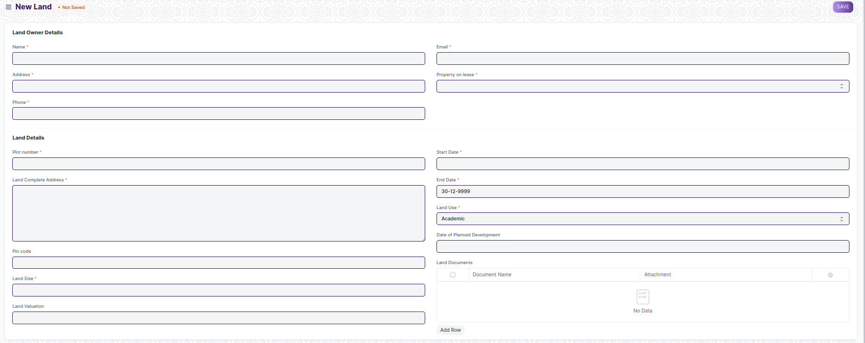

Figure : Land

## Building

Description: This is a master screen for buildings. All the building information shall be stored here including documents like Building Letter(Records of right and Building design), Fire Approval, Electrical Inspection, etc. The buildings can be residential, academic or both.

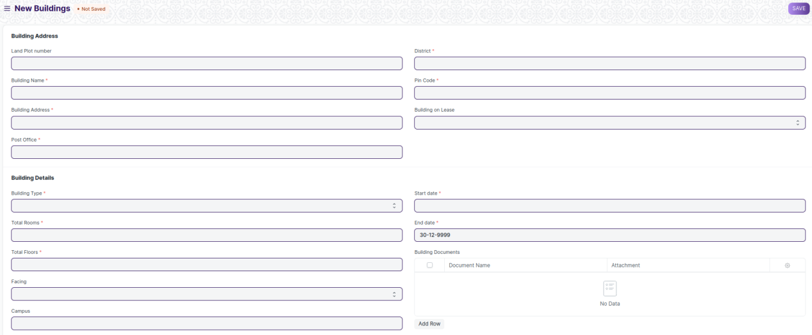

Figure: Building

## Floor

Description: The Floor Master Screen is a screen which will help the user to manage and track the layout of a building's floors and associated fixed assets.

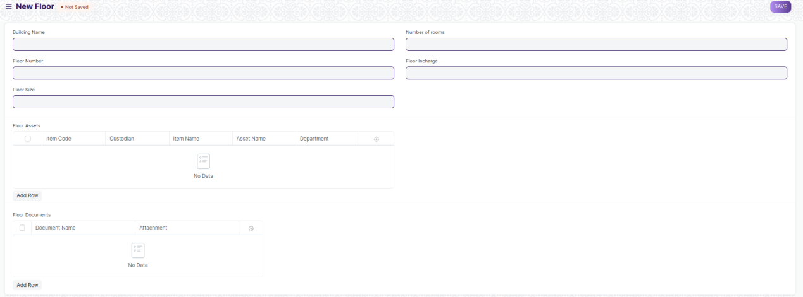

Figure : Floor

## Building Room

Description: **This is a master screen, in which we shall be storing the building’s room details and classifying the rooms. This screen also help us assign a number to the residence ( For e.g, Residence number).**

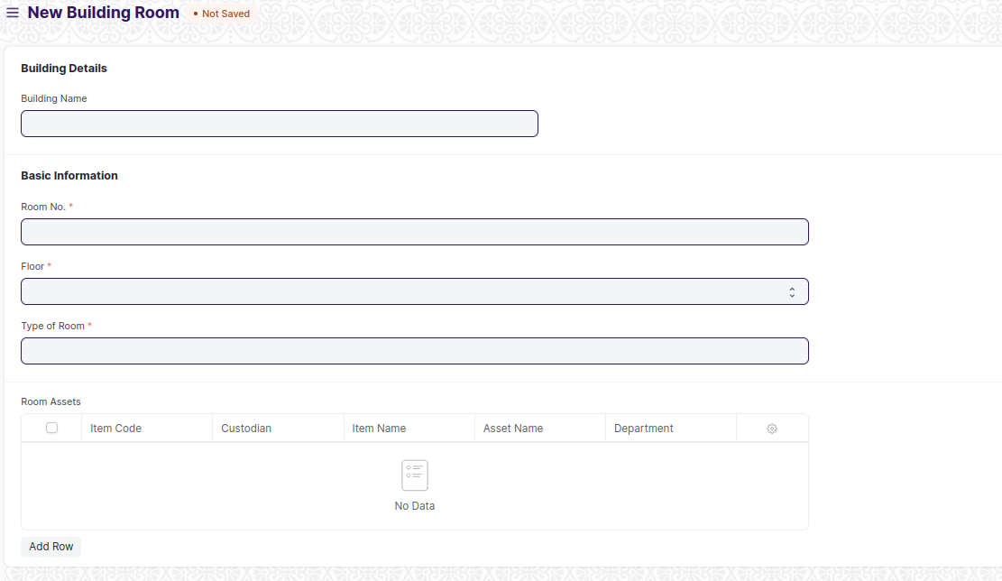

Figure : Building Room

## Building Type Room

Description: **This screen helps define the type of the room, for example if it is a classroom or residential or conference hall.**

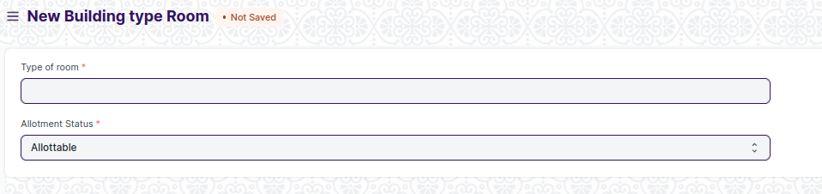

Figure: Building Type Room

## Asset

Description: In Asset, you can maintain fixed asset records for Company assets like computers, furniture, cars, etc. and manage their depreciation, sale, or disposal.

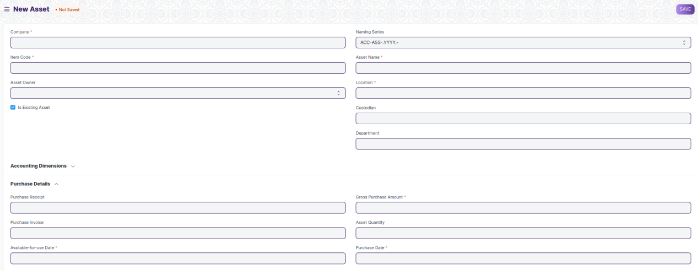

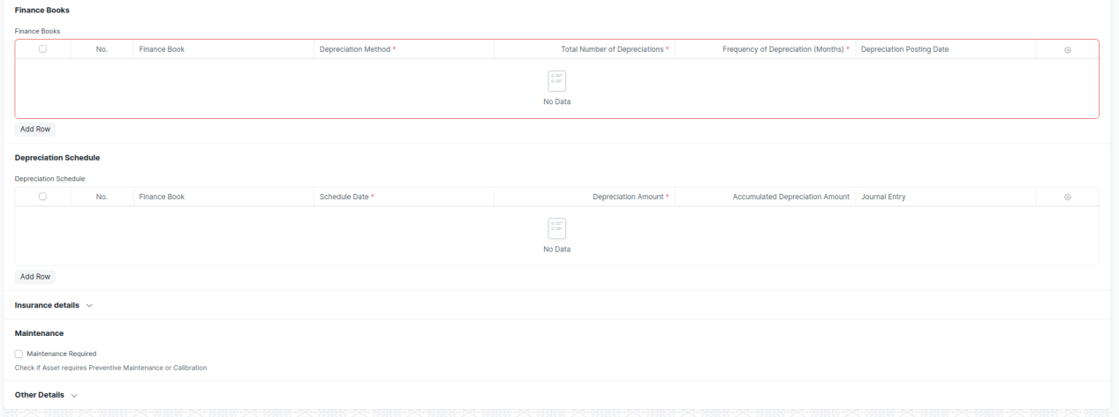

Figure : Asset

## Asset Maintenance Team

Description: The Asset Maintenance Team is responsible for carrying out maintenance activities on the Asset.

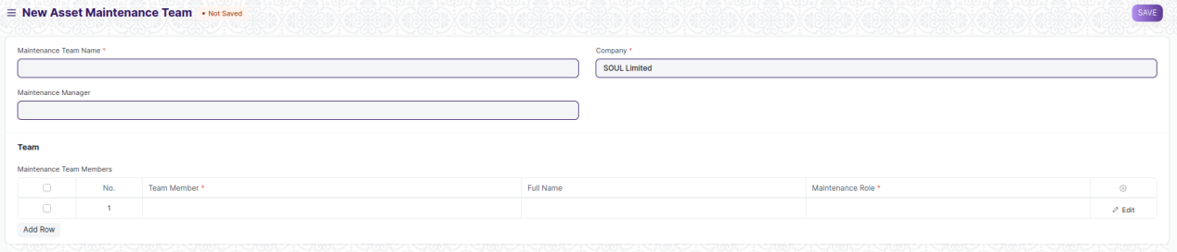

Figure: Asset Maintenance Team

## Asset Maintenance

Description: Asset Maintenance refers to any activity done on Assets to maintain their performance or condition.

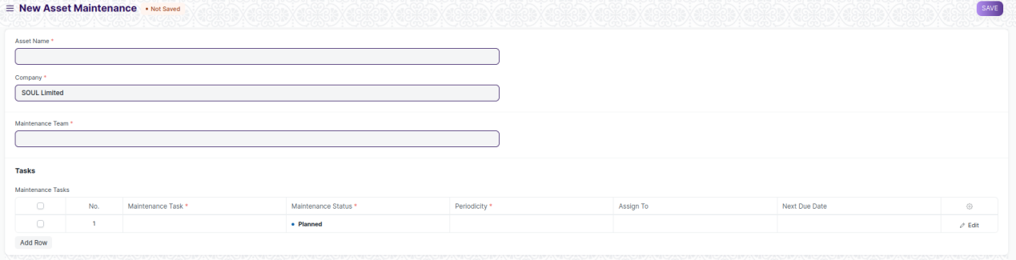

Figure: Asset Maintenance

## Asset Maintenance Log

Description: Asset Maintenance Log logs the tasks carried out in an Asset Maintenance.

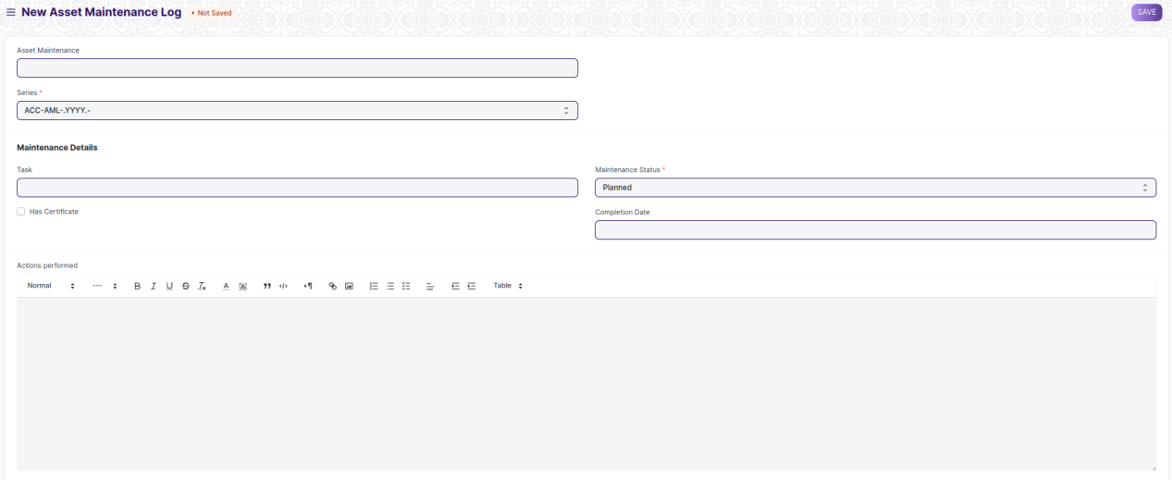

Figure: Asset Maintenance Log

## Asset Repair

Description: Asset Repair refers to any activity carried to repair a broken Asset to restore full functionality.

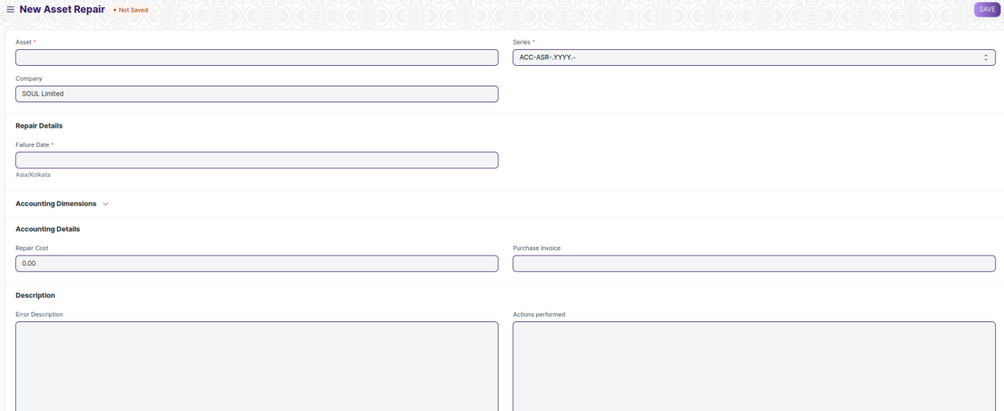

Figure: Asset Repair

# Definitions and Acronyms

The following table explains the terms and abbreviations used in the document:

|  |  |
| --- | --- |
| **Abbreviation** | **Description** |
| HLD | High Level Design |
| LLD | Low Level Design |
| API | Application Programming interface |
| NA | Not Applicable |
| ERP | Enterprise Resource Planning |
| HRMS | Human Resource Management System |
| GDPR | General Data Protection Regulation |
| PCI DSS | Payment Card Industry Data Security Standard |

# Deployment Description

* Application Name: Campus Management Application At World Skill Center (WSC)
* Deployment Environment: Production
* Server Information: IP address:117.250.67.19, domain name:erp.worldskillcenter.org, hosting provider: OCAC
* Deployment Date: 13-06-2023

Database Information: MariaDB 10.6.*, Installed on the same server as the Application